Task 5
Practice task
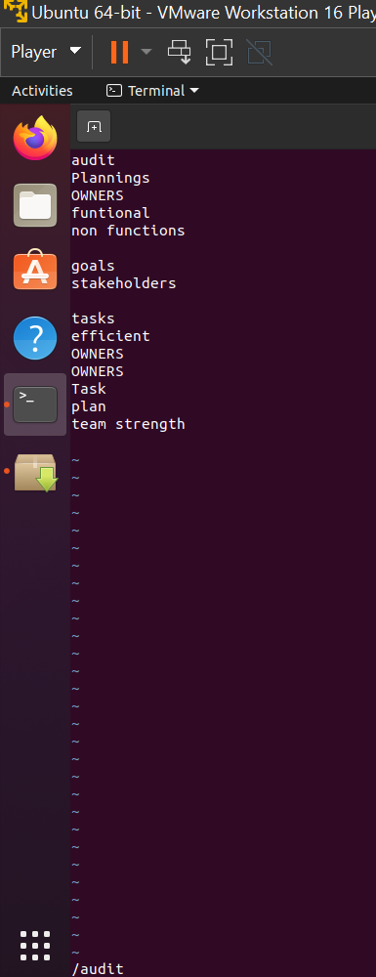
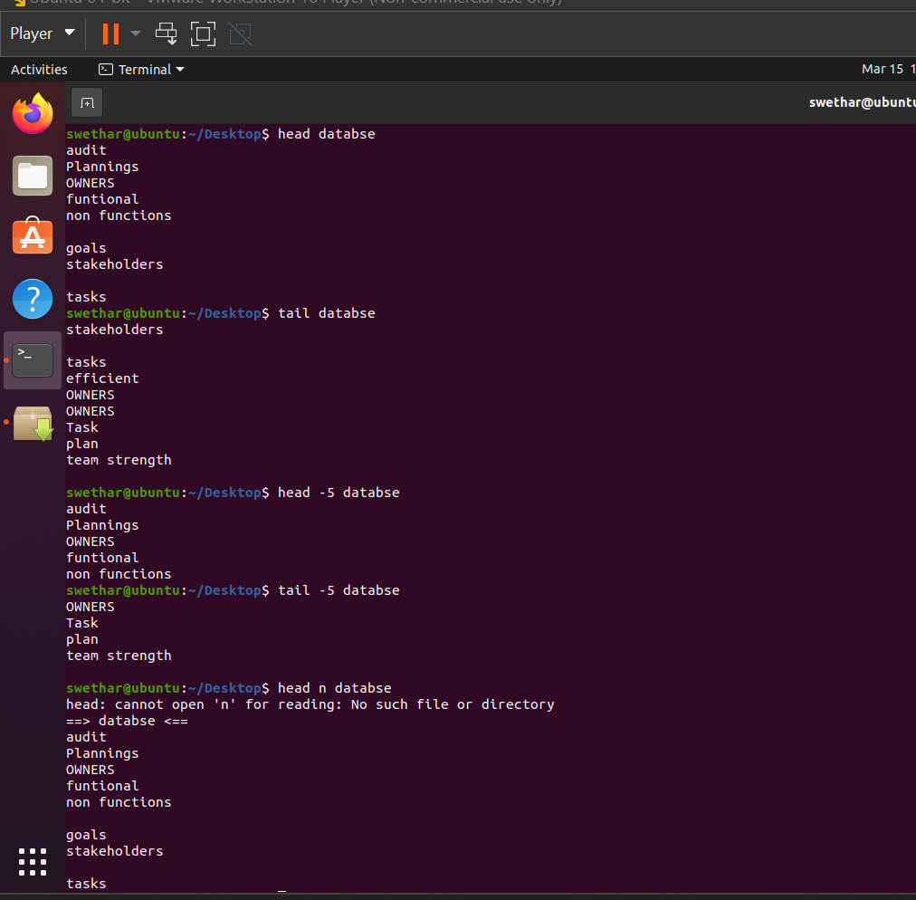
Additional task
1. How to fetch only first and last line of a file using head a tail
head -1 filename | tail -1 filename
2. What is the use of below command
head file1.txt file2.txt file3.txt
Prints first 10 lines in all 3 files
3. How can you suppress file headers when using multiple files?
hint: head -q file1.txt file2.txt
-q (quiet) option removes the file name headers and prints only the file contents.
4. How do you print all lines except the last 10 lines of a file?
head -n -10 filename

